“EnviroMaze!”
A Marble Maze Game made from Clean Reusable materials.
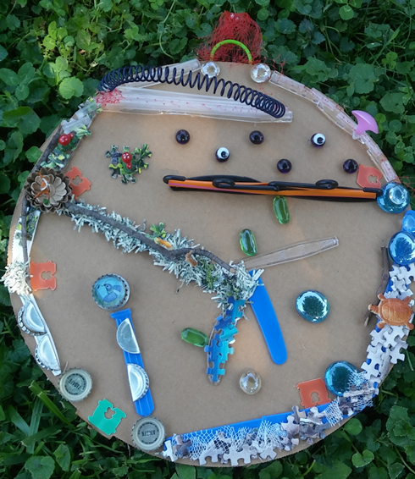

Supplies needed:
Glue
Scissors
Cardboard
Marble

Design Supplies Used:
- Plastic Bread Tie (Single Use Plastic)
- Plastic Garlic Bag Mesh (Single Use Plastic)
- Plastic Cutlery (Single Use Plastic)
- Plastic Straws (Single Use Plastic)
- Plastic Milk Jug Ring (Single Use Plastic)
- Metal Pop Tabs
- Metal Bottle Caps
- Puzzle Pieces (Landfill Bound)
- Expired Shredded US Currency (Landfill Bound)
- Marbles (donated to our ReUZ Room) (Landfill Bound)
- Small Plastic Animals (donated to our ReUZ Room) (Landfill Bound)
- Mesh Onion Bag (Landfill Bound)
- Cardboard Pizza Circle (clean, donated to our ReUZ Room)
- Twigs from backyard (cleaned) (Renewable Material)
- Google Eyes
- Plastic Mini Hangers
- Plastic Spiral Notebook Binder (Landfill Bound)

Basic Game: Start your marble on the green bread clip. Tilt maze board to move marble through the maze. Balance your marble on each of the 4 “Cleanup Spots” (orange bread ties) and do various tasks or answer questions before finally completing the maze by exiting the finish line and making your marble into the mesh basket.

“Cleanup Spots”: These are the 4 orange bread ties placed on the board.
1- The first spot is next to a forest with bottle caps littered around from hikers on the local walking trail. Marble must stop on the orange bread tie to clean up the trail for the animals that live there. (Squirrels, birds, bunnies, and so on).
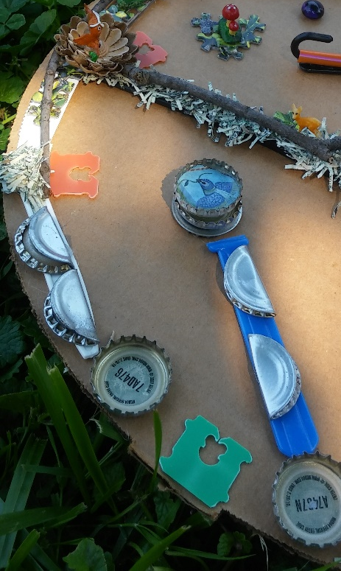

2- The second “Cleanup Spot” is placed next to an aquatic/ocean environment with nets and litter around. Marble must stop on the orange bread tie to clean up the beach for the animals that live there. (Sea turtles live in this environment and are represented on the board).
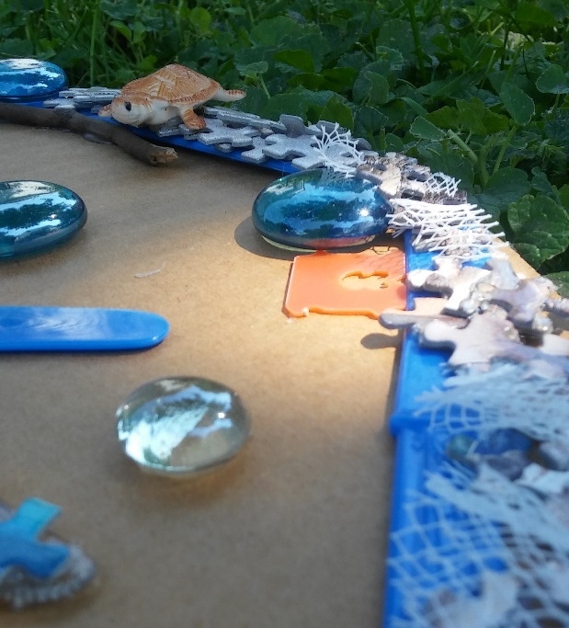

3- The third “Cleanup Spot” is placed next to the owl in the forest environment. Marble must stop on the orange bread tie to clean up the beach for the animals that live there. (Owl, deer, birds live in this environment and are represented on the board).
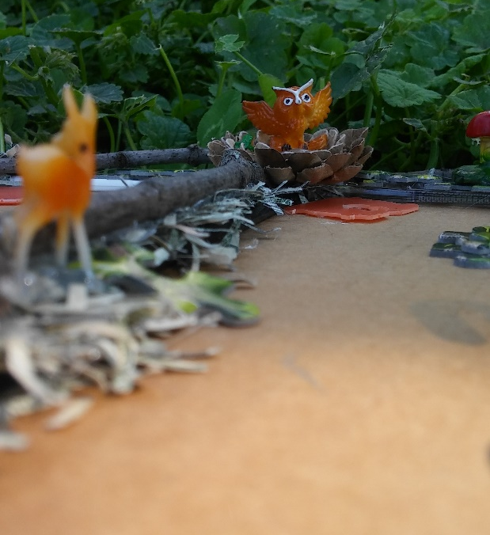

4- The fourth “Cleanup Spot” is placed next to the Plastic Pollution Zone...Marble must stop to clean up the straws, plastic bags and other litter created by humans.
Also note: This “zone”/environment is different than the other Cleanup Spots on the board. Rounds may ask you to do different tasks on this Cleanup Spot.
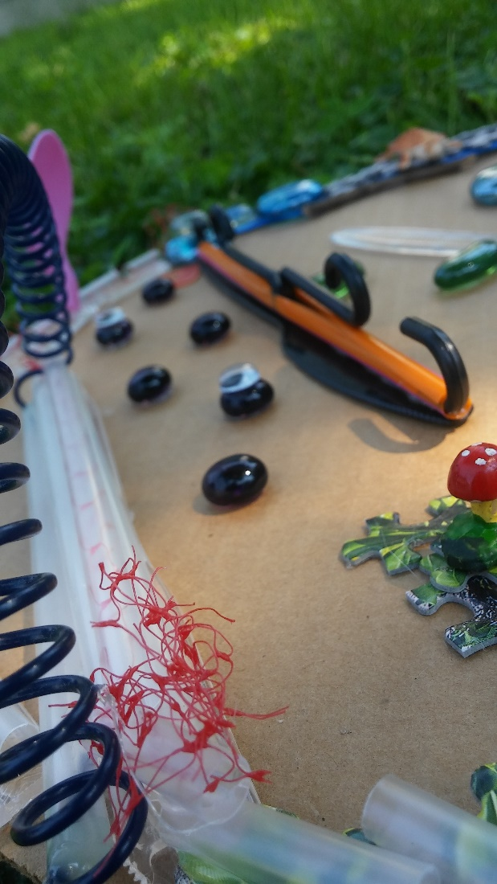
------
*Memory Hint - This game is also about relying on your memory. You may need to remember your answers from a previous round to help with the following round, and if you don’t remember... You will have to restart the LAST round AGAIN! Hint: You do NOT want to restart old rounds and fall behind, so concentrate ;)
**Timed- Rounds can also be timed with a stopwatch and replayed again and again to beat your best times!
***NO REPEATING, only NEW, FRESH answers and ideas can be used- Players can never repeat an answer from previous rounds UNLESS asked to in the directions. If player reuses an answer they must go back and repeat the last round. (I.e. If in one round a player lists “water bottle” as something they can recycle, they cannot use “water bottle” as an answer again.)
If playing with multiple people take turns going through the maze. If one person does not pass a round, they must pass it to the next person and replay that round until someone completes all the rounds. The first person to make it through all the rounds WINS!
If players complete the last round at the same time, they must add up their times on the “Timed” Rounds and the person with the least amount of time WINS!

ENVIROMAZE! Kindergarten – 1st Grade Game
Round 1: Complete the EnviroMaze (without stopping at the “Cleanup spots”).

Ask if they can imagine/see the different environments depicted on the board (Forest with grass, twigs/logs, mushrooms, deer, greenery; Ocean with water, sand, sea turtle)
Now ask if they can see any garbage or litter in these areas (bottle caps, nets on beach, straws, plastic bags, mesh nets)

Round 2: Players must stop and land on all 4 “Cleanup Spots” for 2 “Mississippi seconds” each before completing the maze. **Timed
Round 3: Players must stop and land on the first 3 “Cleanup Spots” and list 1 animal that lives in the “environment” their marble is currently in. Once player lands on the 4th Plastic Pollution Zone “Cleanup Spot” player must list 1 type of garbage that is commonly littered outdoors.
Round 4: Players must stop and land on the first 3 “Cleanup Spots” and list 1 different animal that lives in the “environment” their marble is currently in. Once player lands on the 4th Plastic Pollution Zone “Cleanup Spot” player must list 1 different type of garbage that is commonly littered outdoors. *Memory Hint **Timed
Round 5: Players must stop and land on all 4 “Cleanup Spots” and shout “I love the Earth!” before completing the maze. *This round will be timed from beginning to end. Fastest time “wins” round. **Timed

ENVIROMAZE! 2nd - 3rd Grade Game
Round 1: Complete the EnviroMaze (without stopping at the “Cleanup spots”).

Ask if they can imagine/see the different environments depicted on the board (Forest with grass, twigs/logs, mushrooms, deer, greenery; Ocean with water, sand, sea turtle)
Now ask if they can see any garbage or litter in these areas (bottle caps, nets on beach, straws....in straw zone?? (LOL)

Round 2: Players must stop and land on all 4 “Cleanup Spots” for 4 Mississippi seconds each (to clean up the litter in that environment) before completing the maze.
Round 3: Players must stop and land on all 4 “Cleanup Spots” and shout “Reduce, Reuse, Recycle! Don’t litter!” before completing the maze.
Round 4: Players must stop and land on the first 3 “Cleanup Spots” and list 2 animals that live in the “environment” their marble is currently in. Once player lands on the 4th Plastic Pollution Zone “Cleanup Spot” player must list 2 types of garbage that is commonly littered outdoors.
Round 5: Players must stop and land on the first 3 “Cleanup Spots” and list 2 different animals that live in the “environment” their marble is currently in. Once player lands on the 4th Plastic Pollution Zone “Cleanup Spot” player must list 2 different types of garbage that is commonly littered outdoors. *Memory Hint **Timed
Round 6: Players must stop and land on all 4 “Cleanup Spots” and pick 1 animal on board and explain how they can get hurt by litter in their environment before completing the maze. *Memory Hint **Timed

Now that we have all agreed that our human “garbage/waste” does not belong in our natural environments where it can harm wildlife and others, lets focus on what we SHOULD do with our waste (garbage and recycling).

Round 7: Players must stop and land on all 4 “Cleanup Spots” and name something that you have put in a recycling bin before completing the maze.
Round 8: Players must stop and land on all 4 “Cleanup Spots” and name something that CANNOT be recycled in your recycling bin before completing the maze.

ENVIROMAZE! 4th-6th Grade Game
Round 1: Complete the EnviroMaze (without stopping at the “Cleanup spots”)
Ask if they can imagine/see the different environments depicted on the board (Forest with grass, twigs/logs, mushrooms, deer, greenery; Ocean with water, sand, sea turtle)
Now ask if they can see any garbage or litter in these areas (bottle caps, nets on beach, straws, mesh nets, plastic cutlery, plastic bags)
Round 2: Players must stop and land on all 4 “Cleanup Spots” (to clean up the litter in that environment) for 4 “Mississippi seconds” each before completing the maze.
Round 3: Players must stop and land on all 4 “Cleanup Spots” and shout “Reduce, Reuse, Recycle! Don’t litter! Clean the Earth!” before completing the maze.
Round 4: Players must stop and land on the first 3 “Cleanup Spots” and list 2 animals that live in the “environment” their marble is currently in. Once player lands on the 4th Plastic Pollution Zone “Cleanup Spot” player must list 2 types of garbage that is commonly littered outdoors.
Round 5: Players must stop and land on the first 3 “Cleanup Spots” and list 2 different animals that live in the “environment” their marble is currently in. Once player lands on the 4th Plastic Pollution Zone “Cleanup Spot” player must list 2 different types of garbage that is commonly littered outdoors. *Memory Hint **Timed
Round 6: Players must stop and land on all 4 “Cleanup Spots” and pick 1 animal on board and explain how they can get hurt by litter in their environment before completing the maze. *Memory Hint **Timed

Now that we have all agreed that our human “garbage/waste” does not belong in our natural environments where it can harm wildlife and others, lets focus on what we SHOULD do with our waste (garbage and recycling).

Round 7: Players must stop and land on all 4 “Cleanup Spots” and name something that you have put in a recycling bin before completing the maze. *Memory Hint
Round 8: Players must stop and land on all 4 “Cleanup Spots” and list a way to reuse that same recyclable item (as listed in the last round) before completing the maze. **Timed
Round 9: Players must stop and land on all 4 “Cleanup Spots” and list 1 item that CANNOT be recycled before completing the maze. *Memory Hint
Round 10: Players must stop and land on all 4 “Cleanup Spots” and name something that can be recycled BUT ONLY AT SPECIAL LOCATIONS (visit www.LCSWMD.com for help) before completing the maze. **Timed

