“EnviroMaze!”
A Marble Maze Game made from Clean Reusable materials
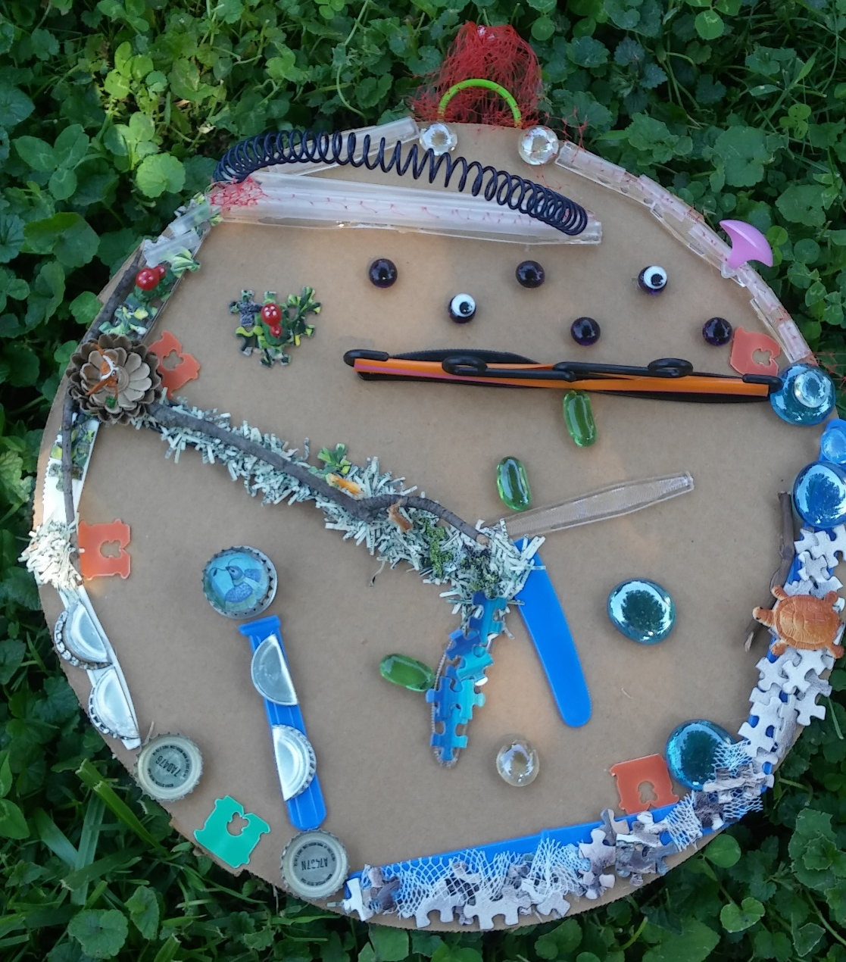

This is a fun game and way to REUSE things you may have laying around the house. To make this game you do not need the exact design supplies I used in this version. You can build your own CUSTOM game that will be one of a kind!

Take an adventure through this game by building a world of your own. It’s up to you to paint the players a picture of what is happening in your world and how players can help make it the best world possible by keeping it healthy and clean!

You can have all kinds of different challenges the players must face to complete the game. For instance, in my version I am highlighting pollution by way of human littering. Examples of other challenges may be deforestation, water pollution, oil spills, climate change, or illegal dumping.

*REMEMBER*
When exploring for supplies remember that single use plastics (plastics that cannot be recycled and made into a new product) and landfill bound materials (like used twist ties, puzzle pieces or broken rubber bands) are the best choice to give them NEW LIFE. Even take the exploration outside to collect dry sticks and pebbles!
*It is a good idea to look at the “EnviroMaze- How to Play” document to get a better idea of how the game is played. *

After your EnviroMaze is complete play your heart away!....But if the game gets easier over time don’t worry... you can always add or change the rounds to adjust difficulty! The possibilities are endless!

Supplies Page

Supplies needed:
Glue
Scissors
Cardboard
Marble

Possible supplies on hand:
- Plastic Bread Ties (Single use Plastic)
- Used Twist Ties
- Plastic Garlic Bag Mesh (Single use Plastic)
- Plastic Cutlery (Single use Plastic)
- Plastic Straws (Single use Plastic)
- Plastic Milk Jug Ring (Single use Plastic)
- Metal Pop Tabs
- Metal Bottle Caps
- Puzzle Pieces (from an incomplete puzzle)
- Paper Scraps
- Small Plastic Animals
- Small Pictures from magazines
- Mesh Onion/Potato Bag (Landfill Bound)
- Cardboard
- Twigs from backyard (cleaned) (Renewable Material)
- Google Eyes
- Plastic Mini Hangers
- Notebook Binder (from an empty notebook)
- And more!

BUILDING YOUR GAME

- Gather your supplies. The cardboard you use will be the board for your game. Then decide what you want to use for your course layout. This will be the edges/walls your marble follows through to the end. Some ideas of materials you can use for this are popsicle sticks, straws, sticks from your yard, or clean used, plastic cutlery. Glue your walls in place so you have a course to build on. (See Figure 1)

Helpful Hint: If you draw a zig zag/ “S” shaped route, lightly with a pencil, you can build the walls around it. (See figure 2) Later, after walls are glued to your board, you can erase the pencil marks.
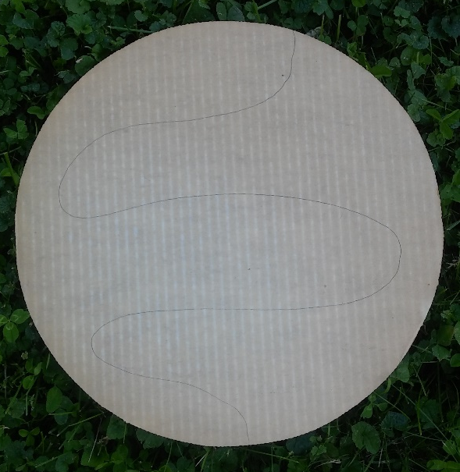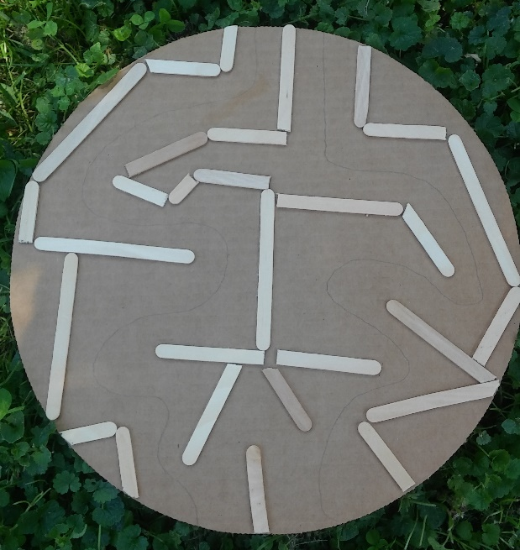
Figure 1 Figure 2

- Now that you have created the base of your course you can decide where your different environments will be placed and glue your “Cleanup Spots” at each environment. I used plastic bread ties (See Figure 3). Also, don’t forget to put something at the Start Line to hold your marble in place until you officially start the round (See Figure 4).

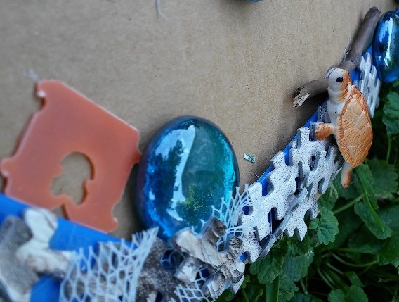
Figure 3 Figure 4

- Now you can start building and decorating your different environments! This part is REALLY FUN, let your imagination take you away! (See Supplies List on Page 3).
Helpful Hints: As you add materials to your board game be sure not to interfere with your marble’s rolling space. Use the boarders and outside space to add features.
Doing a little bit of research goes a long way! If you are “stumped” on what kinds of environments you can create or what kind of animals live in specific environments, look it up! A couple of minutes researching you may unlock ideas and start your creative path rolling!
If you do not have any little animal figurines like this board has, make your own! Maybe you can find small pictures in magazines to decorate with or draw your own. (See Figure 5) This game is also art!
Figure 5

- Now that you have your board game done, it’s time to make your Rounds. This part is also fun! You can refer to the “EnviroMaze- How to Play” document to use those examples or get ideas. Start simple and as the rounds get higher make each round a little more difficult than the last.

- Last, try it out! Maybe grab a family member or friend to join you. Another great thing about this game is you can play alone, maybe on a rainy day when you’re bored 😊

